University of Plymouth

School of Engineering,
Computing, and Mathematics

COMP3000
Computing Project
2023/2024

Multi-modal authentication using facial recognition and keystroke analysis

Alexander Williams

10681389

BSc (Hons) Cyber Security

Acknowledgements

This project was only achievable due to the valuable insights of various people within my academic journey and the motivation to progress within this field of study.

I would like to specifically mention my previous manager Nicholas Sharratt, who helped me develop my interest of user interaction with authentication during my placement year at the University of Plymouth Limited.

I would also like to mention my project supervisor Dr. Nathan Clarke who helped influence my original research-based project into an implemented solution, while encouraging me to develop my skills regarding machine learning to make it a key factor of the product.

Finally, a special thank you to my partner and parents, who encouraged me throughout my entire academic journey, especially when times got tough.

I am extremely grateful for their invaluable insights, encouragement and assistance that has been provided during my academic journey. Your contributions have been core to the creation of my product and academic experience.

Abstract

This document explores the modern-day usage of multi-factor authentication and the intrusions this has on the regular user versus the security needs for the business. The project is a proposition of an alternative method of multi-factor authentication that can be uniquely tailored to any organisation that implements this into their wider system while not being intrusive to the end user. The prototype product investigates the fusion of biometric modalities, being facial recognition and keystroke analysis, as an enhancement to accurate authentication, reducing both security vulnerabilities surrounded with single factor authentication and the frustrating user experience of multi-factor authentication. The product explores methods of authentication that is unable to be replicated by the rapidly evolving genre of Artificial Intelligence.

The background of the project stems from the accessibility of the frequently used options for multi-factor authentication and how these can be circumvented by adversaries. Delving into the capabilities and limitations of current solutions in the industry, which will develop the objectives of the project.

The requirements for the project are then outlined, followed by the legal, social and ethical issues that will be challenged during development of the project. Incorporating the varying factors then informs us to develop the architecture for the application, as well as the method of approach. Furthermore, the report delves into the usability aspects of the multi-modal authentication system, considering user acceptance and experience through qualitative feedback and usability testing. This feedback is reflected within the design of the system to allow for a better user experience which can be tailored to the individual.
The development process is then detailed, discussing the five main stages of development are discussed, which presents the overarching importance of each individual part of development, the challenges and the importance of each section. Development changes are then further explained by the accompanying testing section, ensuring that the end product met all objectives.

The report concludes with a reflection on how the project developed and which objectives were met. This also discusses the changes that were highlighted throughout development as well as a section detailing future developments and lessons learned.
To conclude, the product contributes within the field of authentication with demonstration of multi-model biometric authentication, with the effectiveness of using key biometrics such as facial recognition and keystroke analysis. The findings can be used for enhanced security and end user experience within system’s authentication, offering a practical implementation for policy makers and system developers.

Contents
Acknowledgements 2
Abstract 2
1. Introduction 7
2. Background and Objectives 8
2.1 Overview 8
2.2 Alternative Solutions 8
2.2.1 Google/Microsoft Authenticator/Authy 8
2.2.2 One Time Codes via SMS or Email 9
2.2.3 Limitations 9
2.3 Objectives 10
3. Requirements 12
3.1 Functional Requirements 12
3.1.1 Core Requirements 12
3.1.2 Desirable Requirements 13
3.2 Non-Functional Requirements 14
3.3 User Stories 15
3.3.1 User 15
3.3.2 Admin 15
4. Legal, Social, and Ethical Issues 16
4.1 Legal 16
4.1.1 General Data Protection Regulation 16
4.1.2 Data Protection and Security 16
4.1.3 Licensing 16
4.2 Social and Ethical 16
4.2.1 Use of Machine Learning 16
4.2.2 Accessibility 16
5. Method of Approach 17
5.1 Agile 17
5.2 Scrumban 17
5.3 Technologies Used 17
5.3.1 Trello Board 18
5.3.2 GitHub 18
6. Design and Architecture 20
6.1 User Interface Design 20
6.2 Design Principles and Patterns 21
6.2.1 Observer Pattern 21
6.2.2 Singleton Pattern 22
6.2.3 Strategy Pattern 22
6.3 Database 22
6.4 Application 23
6.5 Security 24
7. Implementation 25
7.1 Research 25
7.1.1 Accessibility 25
7.1.2 Machine Learning 25
7.1.3 Facial Recognition Technology 26
7.1.4 GUI Technology 26
7.2 Application Setup 27
7.2.1 Database 27
7.2.2 Webcam Feed 27
7.2.3 Sign In and Sign Up Function 28
7.3 Authentication Functionality – Core Functionality 28
7.3.1 Facial Recognition Implementation 29
7.3.2 Keystroke Analysis 29
7.3.3 Confidence Score 30
7.4 Non-Functional Features 31
14.1 Maintenance and Report 31
15. Testing 32
15.1 Test Driven Development and Integration Testing 32
15.2 Functional Testing 32
16 End of Project Report 34
16.2 Summary 34
16.3 Objectives Review 34
16.4 Changes In Development 35
17 Project Post-Mortem 37
17.2 What Went Well? 37
17.3 Lessons Learnt 37
17.4 Future Development 37
18 Conclusion 38
19 References 39

Introduction

The product that has been researched, designed, and implemented is aimed at enhancing security for organisations while also considering end user interaction at the forefront of the design process. The primary requirement of the product is to allow for flexible authentication where the organisation may tailor the experience of the user depending on the authentication resultant of the various methods implemented for access control. The multi-factor approach has been designed to be non-intrusive to users, not requiring either a third-party app or device, and for the interaction to be as simple as them starting their day by logging in.

The primary objective of the product is to build a report on each individual user’s individual typing habits when they are trying to login to their system. There are two key biometrics that are unique to all users that are used to build this report – facial recognition and keystroke analysis. The product will result in giving an overall confidence level which is resultant of varying authentication methods, varying from low to high. This value will then be used by an organisation for their own access control needs allowing for stronger security implementation.

Background and Objectives

Overview
There are many variations of multi-factor authentication, ranging from one-time codes to physical devices that act as an authenticator. However, many of these variations rely on having strong random generation and the secret key (seed) not being leaked. There are varying factors, also such as adversary in the middle attacks that could potentially gain one-time codes if SMS option was selected.

Alternative Solutions
In this section of the report, we will discuss alternate solutions that are currently used for multi factor authentication, what we can learn from them and the limitations of each implementation. These limitations will therefore influence the design of the application and the project objectives.

Google/Microsoft Authenticator/Authy
These are both popular multi-factor authentication solutions that are favoured by many. When a user is adding multi-factor authentication to an account, the user would scan a QR code which would integrate the account into the application. The applications then generate unique time-based one-time passwords (TOTP) which act as the multi-factor.

To generate these codes, there are a series of factors in place. A shared secret between the application and the authenticator that is unique to the account and a time vector. Due to the symmetric cryptography in use, it allows for either application to be able to calculate the TOTP. This form of authentication is generally favoured by users due to its simplicity in setting up and ability to access as researched by Usenix (Reese et al., 2019). However, the limitation with this study is that their tested audience were university students, who generally can be more tech savvy.

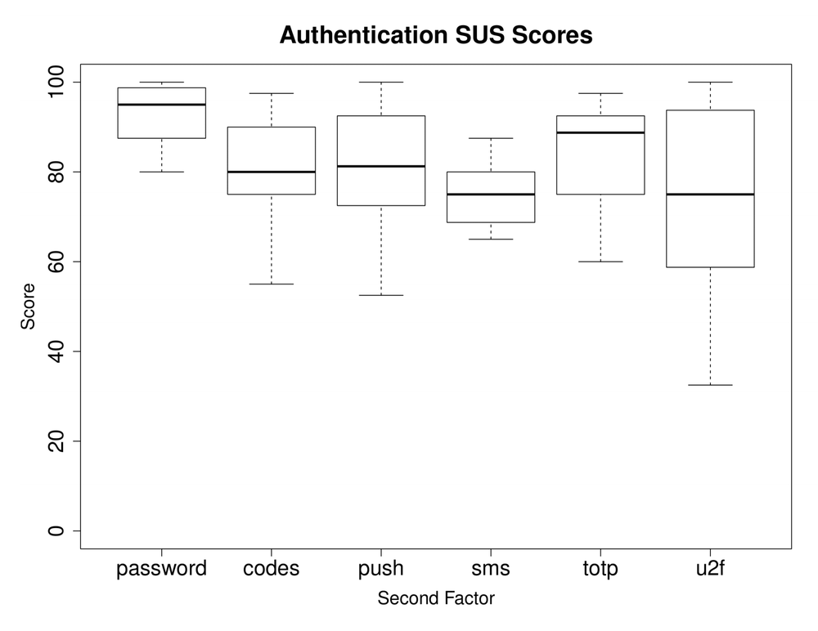
Figure 1: Authentication System Usability Scale Scores - Usenix

One Time Codes via SMS or Email

This is generally the worst rated method of MFA for usability score as shown in the study previously mentioned. OTPs function very similarly to TOTPs as the server-side will be generating an OTP using a variety of functions, however this doesn’t take time or a shared-secret in as a factor. The website requesting the OTP will generate the code and send this to the user through their requested channel (Twilio, One-time passcode verification (OTP)). This is generally considered less secure due to the channels being more vulnerable to attacks than software tokens as there are other factors at play for generating the codes, as well as access.

Limitations

While these forms of authentication are generally favoured by the population, they are not without drawbacks.

A key example of limitations within using Authenticator apps is the requirement of secondary equipment. If a user is unable to access the device with their authenticator, they are at an impasse. Although this is beneficial for account security as it prevents unauthorised access with compromised credentials, it can cause work-day disruptions.
Secondarily, if a user loses said device, it can be generally quite difficult to remove from their account without contacting IT support. While this does mitigate the risk of an attacker maintaining persistence if the account becomes compromised, it can lead to end user frustration.

Regarding the limitations of OTP via Email and SMS, these are unable to be computed offline due to there being no shared secret. This then has a reliance on network and internet accessibility to access this code. This generally interferes with the user’s experience as they now must wait for external factors at play. Furthermore, both SMS and Email are generally more vulnerable. SMS messages can be intercepted and spoofed so that the end user never receives the codes, but an adversary could instead. If an adversary has compromised multiple accounts and they are able to access the victim’s email, they are able to bypass MFA as they would also have access to the codes.

Generally, the use of SMS based OTP is considered less secure due to the risk of adversary’s being able to access the code due to external factors. As there is reliance on network service, these codes are often designed to have a longer time to live, while also having less entropy (Lei et al., 2021). Therefore, they are at a higher security risk for an adversary to spoof or intercept the code.

Objectives

The aim of the project is to create a non-intrusive form of multi-factor authentication using varying biometrics which can be used by companies and privacy-conscious users to enforce access control to systems. Therefore, the objectives for the project are as follows:

- To research user experience (UX) interface design to allow for the application to be accessible to all users.
- Build an application that uses multiple biometric modalities to authenticate.
- Build an application that allows for enforcement of access control for each individual authentication attempt.
- Design a user interface that is accessible and intuitive.
- To follow agile project management techniques and complete a minimum viable product within the allocated time.
- Create an unintrusive method of application to ensure users aren’t disrupted.

Requirements

Functional Requirements

For development of the application, a series of requirements were created aligned with the project objectives. The categories that the requirements were split into were core and desirable. Core requirements are required for the minimum viable product and to achieve functionality aligned with project objectives. The desirable category are other requirements that greatly enhance the application and will aim to be included in the prototype. However, it is not feasible for all desirable requirements to be complete within the time frame of the project.

Core Requirements

3.1.1.1 Login System

The product is required to have an entire login system where the product is able to generate a confidence score based on the user provided information. This will allow for a user to type their username and password, while also providing a series of images that will be used by the facial recognition system. The system will record the keystrokes and pass the data to the rest of the application.

3.1.1.2 Register System

A register system to allow for user enrolment within the application will be required. This will allow for a user to submit a username, password and an image of themselves that will be used for all future authentications. The register system will also record the keystroke pattern of the user and generate a user table for future attempts.

3.1.1.3 Facial Recognition

The first main modality of authentication for the product will be facial recognition. The application will have a base user photo from when they registered, and during every attempted authentication attempt, several photos will be taken of the user. The comparison photo and the new user photos will then be tested against each other using the facial recognition technology to determine an overall confidence score of the user specifically for this modality. As facial recognition technology is a very proven method of authentication, this will count more towards the overall confidence score than other modalities.

3.1.1.4 Keystroke Analysis

The second modality of authentication for the product will be keystroke analysis. This will use a machine learning model with binary classification to determine whether the keystroke pattern of the attempted authentication attempt is consistent with what the system would expect. Based off the binary classification prediction, a confidence score is then generated to determine whether the authentication is legitimate or not. However, due to the small sample size until consistent use and integration, this will not generate consistent scores. This will count towards less of the overall confidence rating due to this.

Desirable Requirements

3.1.2.1 Face Liveness
This is the third modality of authentication. This would take the image that has been provided during the login system to detect whether the image provided is a live image from a feed. This would allow for detection of AI generated images or videos of the user that may have been used to spoof the system. This is an additional feature that would be added in.

3.1.2.2 User Management System

This system would allow for administrators within the application to be able to view all current and deleted accounts. They would have a variety of options ranging from deleting an account or recovering them. They would also force a user to reset their password.

3.1.2.3 Password Reset System

This system would be available for all users and would allow upon login to change their password. This system would update their relevant data to remove any regarding previous passwords.

3.1.2.4 Photo Update System

This would allow for users to change the photo that is registered in the database for their account. This would be locked behind a confidence score within the application, requiring a minimum confidence score before allowing for the user to change the photo. This would mitigate the risk of a compromised account being able to spoof the account. If the confidence score wasn’t met, they would have to re-authorise or use an alternative third-party authentication method.

3.1.2.5 Accessibility Settings

To ensure that the application is accessible for all range of users, there will be an additional option within the application that will allow for users to change a variety of accessibility options within the application. The main options would be font, font size and theme i.e. light or dark theme.

Non-Functional Requirements

Non-functional requirements are defined as overall requirements that are not concerned with the specific functionality of the system, but a list of requirements that the application must meet.

- Usability: The application is intuitive and user-friendly for all skill levels.
- Reliability: The application should not fail or disrupt the user.
- Effectiveness: The application should reduce the intrusiveness of multi factor authentication without compromising security.
- Accuracy: The application should be able to accurately classify the user’s authentication attempt.
- Performance: The application shouldn’t be disruptive to user and should be quick.
- Testability: All parts of the system should be testable through development.
- Documentation: The system should be documented for future development.

- Accessibility:

- Accuracy: The application should be able to accurately
- Documentation: The system should be documented for future development.
- Flexibility:
- Performance:
- Testability:
- Usability
- Safety:

User Stories
User stories are general explanations of features for an application written from the perspective of a user (Atlassian, User stories: Examples and template). These user stories act as an end goal rather than tasks that can be ticked off in sprints. Using user stories ensures that the product stays focused on the user, and allows for end goals to be broken down into smaller, achievable chunks that can be implemented.

User

- As a user I want to be able to enrol within the programme.
- As a user I want to be able to sign in to the programme.
- As a user I want to be able to view the progress of the authentication.
- As a user I want to be able to change my password.
- As a user I want to be able to update my photo.
- As a user I want to be able to change the font of the application.
- As a user I want to be able to change the font size in the application.
- As a user I want to be able to change the colour theme of the application.

Admin

- As an admin I want to be able to view all users.
- As an admin I want to be able to delete existing users.
- As an admin I want to be able to recover users.

Legal, Social, and Ethical Issues

Legal

General Data Protection Regulation

Data Protection and Security

Licensing

Throughout development of an application, it is a requirement as a developer to ensure that all external assets are either public use or have permission for use. All libraries, code and assets within this application all have free use licensing for use on personal projects, A full list of resources can be found in the Appendix.

Social and Ethical

Use of Machine Learning

Accessibility

Method of Approach

Agile
The project has adopted the agile methodology to ensure that development is completed within the required timeframe and to review progress of the project. There are two main forms of agile development, Scrum and Kanban. Scrum divides development into fixed-length iterations known as sprints, and each sprint has a set of prioritised list of user stories and sprints that are required to be completed. Each sprint follows the cycle of planning, executing and evaluations Atlassian, What is agile?). Kanban doesn’t work in sprints, but instead works with a visual board (frequently known as a Kanban board) which allows for continuous improvement to tasks within the project and ensuring that workflow is optimised by limiting the amount of tasks that are work-in-progress.

Scrumban
While there are two key methodologies of agile, the project will adopt the intermediate methodology, Scrumban. Scrumban combines the best features of both Scrum and Kanban into a hybrid project management framework. The result is a flexible approach to development due to the range of agile tools that are accessible (Atlassian, Scrumban: Mastering Two agile methodologies).

From the scrum approach, we are adopting the use of sprints, also using the sprint planning and retrospectives. From kanban, we are adopting the use of a visual board to keep track of development as well as limiting the number of work-in-progress tasks. The use of a visual board allows for development to be kept accurately tracked of with the use cards including descriptions of tasks and any iterative developments throughout each sprint.

Technologies Used

This section will discuss the varying technologies that have been used to meet the techniques that are required for agile development to be successful.

Trello Board

From the benefits of using Scrumban comes the development board from Kanban. To ensure that the project stays organised and to ensure that we limit work in progress tasks, a Trello board was used. Trello is an online visual tool to ensure project-space organisation is well managed and can be easily interpreted. The board is easily able to inform what is in the backlog, what is currently being worked on and what has been completed (Trello, 2023).
The board used was divided into five sections:
- To Do: This acted as the product backlog.
- Doing: This acted as which tasks were being performed during the sprint or required future work.
- Testing: This acted as a section for when tasks were fully developed but required testing to ensure quality.
- Done: This section held every task that had been completed and fully tested.
- Other Tasks: This section contained all non-functional and desirable features.
The below figure shows an example of the Trello board:
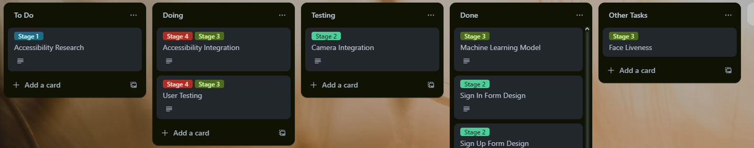

Each kanban card was assigned a label associated with a stage of development. This allowed for consistent review of any work that was behind schedule and what needed to be progressed. With the visual prominence of each column, this helped ensure that the work-in-progress limit was enforced and regularly reviewed.

GitHub
Due to the complexity of the project, it is vital that a method of version control is implemented before any development began. Using version control is industry standard as it allows for larger teams to tackle a project. It includes a complete long-term change history of every file that is within a repository (Atlassian, What is version control), along other benefits such as branching and long-term change history of every file.

The product’s codebase has been maintained using Git Source Control Management (SCM) and is hosted on GitHub. Having the codebase hosted on an SCM allows for the prevention of loss of data in event of local hardware error or corruption. With the GitHub being a centralized repository, this allows for the access and continued development of the project in event of significant hardware failure.
To ensure that very little is lost in event of hardware failure or corruption, there should be frequent commits to the codebase; allowing for the developer to roll back to previous versions, allowing for quick recovery. GitHub also allows developers to create individual branches off of the master branch which allows for individual features to be developed on their own branch without risking the lack of a working solution on the master branch. Finally, GitHub allows for easy management of documentation for the project, allowing for varying files that will be required for the overall project rather than just the codebase itself. This allows for readme files for information regarding the project to be easily displayed for potential users.

Design and Architecture

The product is designed with the user experience at the forefront of the design and limiting the intrusion of the multi-factor authentication.

The strongest method of authentication that we can provide is biometrics due to the uniqueness for every individual. It is a challenge for adversaries to spoof biometrics due to them being core to the individual/user and would require excessive reconnaissance and information gathering for the adversary to be able to spoof these biometrics.

User Interface Design

As the application is an alternative implementation of a system that is used multiple times daily by users, it was important to the design of the application that it followed Human-Computer Interface (HCI) principles to ensure that the application doesn’t cause user frustration while maintaining accessibility. This will be implemented by allowing for users to choose between a light and dark theme, and allowing for users to choose more accessible font families and font size for the individual.

The eight golden rules of interface design that will be followed were researched (Schneiderman et al., 2017) and are globally followed by designers. The principles being followed are:
- Strive for consistency.
  - Use familiar icons, colours and user-flows that the user may be familiar with.
- Enable users to use shortcuts.
  - With frequent use, the desire to use quicker methods for completing tasks.
- Offer informative feedback.
  - Ensure that user’s are aware of what is required of them at all stages of use.
- Design dialogue to yield closure.
  - Ensure that all dialogue provided to the user ensures the user’s understanding of what has occurred.

- Offer simple error handling.
  - Ensure that remediation actions are accessible and easy to understand to all end users.
- Easy reversal of actions
  - After a user has completed any action, there should be an obvious but unintrusive option to reverse their action.
- Support internal locus of control.
  - Ensure that the user feels like they are making the application progress. This is done by making sure there are no redirects within the application without control from the user.
- Reduce short-term memory load.
  - Ensure interfaces are simple with proper information hierarchy for quick recognition.

Due to the limited scope of the application, not all the principles will be as applicable as others. The main principles that will be implemented throughout design is consistency, informative feedback, simple error handling and short-term memory load.

Design Principles and Patterns

The product will follow a handful of design principles and patterns throughout development. Following design patterns allows for the developer to keep code readable and expandable, using proven methods of development rather than requiring the developer to start from scratch.

6.2.1 Observer Pattern

An Observer pattern allows for a subscriber to register and receive notifications from a provider (IEvangelist, Observer design pattern - .NET). This will be used frequently throughout the programme to update any interfaces that are gathering information from another form. This will mainly be demonstrated on our real-time form where it subscribes to the login page for information about where in the login process it is.

6.2.2 Singleton Pattern

The singleton design pattern allows for only a single instance of the class to ever be created at once. This ensures that during authentication, there is only ever one user that is stored as the current instance. It also provides a global access point to the instance to ensure that all child processes can access the class. This also ensures that there is no chance of duplicate forms being open, causing problems with webcam feeds.

6.2.3 Strategy Pattern

This design pattern is commonly utilized within software development that enables the definition of groups of algorithms that users are able to select during run time (Tanrıverdi, 2024). Our implementation won’t be directly specified by the user, but by what biometrics have been input to us. The key one will be facial recognition, as it is not a requirement and is hardware dependent on the user.

Database

The database that is being used is SQL Server, which has been stored in Amazon Web Services’ (AWS) Managed Relational Database Service (RDS). Initially the host of the database was intended to be Microsoft Azure, however due to the application already using AWS, RDS was selected to centralise the technologies being used within the project. RDS allows for the online hosting of the data being used by the application that is

The database component of the application has been implemented using SQL Server hosted on Amazon Web Services’ (AWS) Managed Relational Database Service (RDS). An alternative solution for hosting was Microsoft Azure due to their free services as a student, however AWS was selected due to multiple reasons:

- Centralisation – As other aspects of the project will be using AWS; it was deemed more efficient to keep the services centrally hosted rather than using varying services.
- Cost – AWS offers a generous free tier, allowing for the use of a large majority of their services.
- Reliability – With AWS being such a notable company, they have strong incentives to comply with the CIA triad and strong data security to comply with other regulatory requirements.

The design of the database queries was majorly encapsulated using stored procedures, due to their accessibility and security. Using stored procedures, we can reduce the attack surface due to pre-defined logic. Furthermore, it helps prevent SQL injections due to the parameterising of the SQL queries.

Application
The graphical user interface (GUI) that has been developed for this product has been implemented in .NET and Windows Forms. This also allowed for better hardware utilisation when the application is executed and for a strong integration of a separate Python subsection of code for the machine learning aspect of the project. Python was selected as the machine learning language due to the large number of libraries and documentation available for machine learning, as well as its easy integration into the project. The figure below shows the class diagram of how the overarching system interacts with each other.

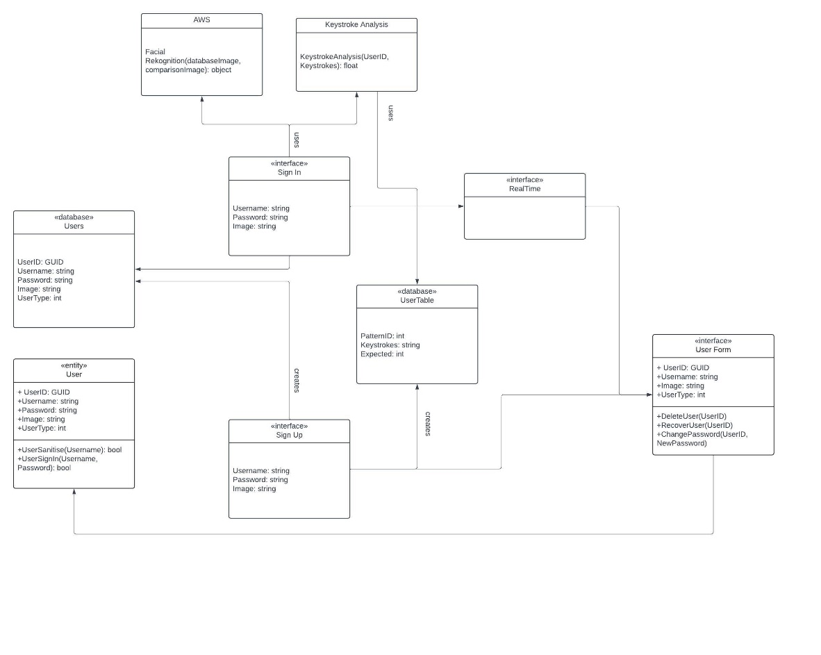

Security

Due to the handling of personally identifiable information (PII), it is of upmost importance that all data is handled security and with careful consideration to ensure compliance with GDPR.

The main two areas of security that need to be handled are user’s passwords and user images. To ensure password security, a strong hashing algorithm should be implemented to minimise the risk of a password being cracked in case of a data leak. At a bare minimum, SHA256 should be used to hash the passwords as advised by the National Institute of Standards and Technology (NIST) (Computer Security Division, 2015). This can be integrated easily within the project to ensure that the passwords are not stored in plaintext. However, SHA256 has many drawbacks such as the lack of salting. Alternatively, a more suitable method of hashing would to use an algorithm such as Argon2. Argon2 is a hashing function that won the password hashing competition in 2015 and uses memory-hard functions, specifically designed to hash passwords (Dinu et al., 2015).

Secondly, how the images are stored is a requirement to explore due to the inherent flaws in storing an image in base64. To combat this, rather than storing the image in the database, feature vectors can instead be stored within the database and used for future comparison. Instead of using a facial recognition library/service, an alternative can be used to analyse the initial sign-up image and return the feature vectors, which can then be stored. This process can then be repeated and used for comparison.

Implementation

Research

Accessibility
The graphical user interface (GUI) will be the prominent use case for the entire prototype application. This requires generous research into user design (UX) and how to make it accessible. The main implementation of accessibility that the product is using is font family and font size. The main accessibility option that this is tackling is those with reading difficulties such as poor eyesight and dyslexia.
While searching for dyslexic friendly fonts, OpenDyslexic was a prominent typeface that has been based on research and had had various studies completed on it. This font is an opensource typeface that is designed against common symptoms of dyslexia by using heavy bottom design (OpenDyslexic).

As researched by Lexdis, a subsection of ECS Accessibility Team at the University of Southampton, copying codes from one device to another can become problematic where concentration or attention is an issue, as may happen with ADHD or other neurodivergent users (Draffan, 2022). Actions that require a user to recognise and copy a code qualify under the W3C WCAG cognitive function test, therefore requiring an alternative method of authentication.

Based on the research, having a simple design UI with a variety of font offerings, while also ensuring that the user can change the font size (as generally [web] applications should have at least minimum size of ten) allows for a more tailored experience. While also incorporating everything that is needed within the application reduces the risk of losing attention of users, taking advantage of the concentration to conduct another type of authentication.

Machine Learning

As the developer was not very familiar with the use and implementation of machine learning, a section of research had to be done into the different methods that can be used for the design of the application. There were a variety of different methods of machine learning that can be applied for binary classification. Binary classification is a task to classify input data into two mutually exclusive categories (Keita, 2022). In this case, we are defining our expected data (legitimate activity) and our poisoned samples (not legitimate activity). The model will then be trained each authentication attempt to classify the new input from the user.

While there are several different methods of classification that can be used, the developer chose to use random forest classification. Due to the limited sample size that will be provided to the model until consistent use, using a random forest classifier allows for improved accuracy by reducing overfitting (Al-Rousan, 2022). Ensuring that the model is not overfitted can result in the training data being poisoned with noise and outliers, and therefore may perform poorly on newer data. It is a necessity that this isn’t implemented due to new data being core to the analysis.

Facial Recognition Technology

As there are a variety of different options available regarding facial recognition, research into which solution would be the most accessible had to be conducted. While there are several libraries available for .NET, such a AForge and DlibDotNet, the developer decided to use an external service to ensure that the function would be completed within the timeframe provided. The options that were researched were Amazon Facial Rekognition, Microsoft Azure Face and Google Cloud Vision. However, the developer chose to use Amazon Facial Rekognition to keep consistency with database development.

However, using Azure Face API may have been a more beneficial selection due to it being generally more accurate and reliable when using facial analysis/recognition tasks.

GUI Technology

The application could have been built in a variety of different methods. Due to the developer’s experience, the code was to be written in either .NET or Python. By using Python, the entire product could have been kept within one coding language. However, to create GUIs there are multiple different libraries that are required to be imported and has a lack of visual development without compiling. Due to this, the developer chose to use Windows Forms, a built in functionality within Visual Studio that has a visual designer that allows for real-time editing and properties changing without the need of compiling.

However, the challenge with using Microsoft Forms is the lack of creative direction you are able to implement using the base product. Research into alternative libraries that can be used were available such as MetroFramework.

MetroFramework is a community created library that brings UI updates from Windows 8 to .NET Windows Forms applications. It allows for greater customisation, and therefore the ability to make the application more accessible. It allows for custom colours and the integration of a light and dark mode. Being able to use custom hex colours will allow for us to ensure that the colour pallet used meets the requirements from Web Content Accessibility Guidelines (WCAG). While our application is not web-content based, the same guidelines can be applied to our application. This ensures that the contrast between displayed text and the background can still be ready by those with moderately low vision (Understanding SC 1.4.3:contrast (minimum) (level AA) 2023).

Application Setup
The second stage of development was to begin the setup of the environment and other technologies being used to begin development.

Database
The database began by being held on a locally hosted SQL database. The initial creation was just a simple users table that took in a user’s UserID, Username, Password, and Image. This had all been documented into a Jupyter Notebook for ease of transition and understanding; the notebook has been updated throughout development to ensure that the end product can be met.

The second table that had been developed was the Keystrokes table. On sign in, a user’s recorded keystroke pattern would be stored in this table along with their unique identifier (UserID). Further into development, this table had been depreciated in favour of using dynamically named tables.

Webcam Feed

Before completing the sign-up function, the ability to display a webcam feed was a necessity. This used external library AForge Video to allow the developer to capture any video devices connected to the device and streamed this to a PhotoBox. The challenge that came with using a PhotoBox was the video stream was not resized to fit within the container. This was implemented by creating a duplicate feed, calculating the aspect ratio and resolution of the video stream versus the PhotoBox, and therefore resizing it. This functionality is repeated in both the Sign Up and Sign in feature.

Once the user had taken their photo, to optimize the programme, the stream is then stopped and instead displayed with photo that had been taken.

Sign In and Sign Up Function

Once the webcam feed was successfully setup, this stage of development successfully allowed for a user to enrol within the application. The images are stored from the memory stream as base64 strings and all other user information is passed into the database using a stored procedure. This will then create a table named after the user, storing all future keystroke patterns that will be used for the keystroke analysis.

The next function will be the sign in function. This takes in a user’s username and password, and if a video device is detected, it takes up to six photos of the user. The images are taken automatically by the application while the user is typing in their password due to already having their concentration, therefore removing an additional step during the authentication process. This also gives more reliability when using the facial recognition function, as there are more samples to compare.

To ensure security within the application, user inputs (that aren’t passwords due to being hashed) are all validated using regex patterns against common patterns such as SQL Injection and Path Traversal. In the case of pattern detection, this will prevent any communication with any other parts of the application.

Authentication Functionality – Core Functionality

The third stage of the implementation was the various authentication modalities. This part of development took the largest allocation of time due to the challenges that occurred during development.

Facial Recognition Implementation

The implementation for the Facial Rekognition API wasn’t a challenge. This took the existing database image and the several new images for a comparison. This function is then called for every image that has been taken. The API will then return a similarity percentage. An average is then calculated for the sum of the images to further validate the images that had been taken.

There is an editable parameter that can be customized for each individual for a “SimilarityThreshold”. This parameter determines the response value, the developer has this currently set to a value of zero to ensure that a response is always given. This will be discretionary to the company, as this could be editable to always assume a constant value if the similarity threshold is below what is requested by the access control.

Keystroke Analysis

The keystroke analysis section is by proportion a lot larger. Due to the limited training samples that are available, the function generates it’s own poisoned samples using standard variations and averages of existing data. This calculation therefore produces a variety of poisoned samples that are similar enough to legitimate data, but with slight variation to teach the model that it should be categorised as unexpected.

To ensure that there is no data imbalance, the amount of poisoned samples generated are directly proportional to the amount of legitimate data. Ensuring there is a data balance between legitimate and poisoned samples mitigates the risk of bias during the training process and also increases the model accuracy.

In the model, there are a variety of parameters that can be edited to be tailored more to company requirements. The parameters that can be edited are:
- The amount of standard deviations added to the average (currently between -2 and 2)
- The amount of random noise that is added (currently between -20 and 20).

Each keystroke set is then calculated using the formula in Figure :
When a new keystroke set has been generated for the length of the password, this is then compiled together, and a new one is generated. Once our poisoned sample set has been generated, this combines into one large data set and is passed into the machine learning model to learn. Once it has completed its learning, it then predicts using binary classification about whether the current inserted sample is consistent with previous samples, returning a confidence score to the application.

The challenge faced within the model was ensuring that integration into the other files were successful, as the outputs that were returned needed to be manipulated to ensure consistent results.

7.3.3 Confidence Score
The finalised confidence score generated will be a weighted calculation of the predictions given by the biometrics.

Due to the keystroke analysis having less accurate predictions with smaller data sets, this will be considered a less viable biometric and therefore have less weighting when calculating an overall confidence score. However, as the application is used for longer and the data set grows larger, this shouldn’t reduce the weighting by a detrimental amount. Research has shown that while keystroke analysis is not a unique identifier, it is able to provide discriminative information, therefore providing valuable information for authentication purposes (Saevanee et al., 2012). With this reasoning, the current confidence weighting is:

Facial Recognition – 60%
Keystroke Analysis – 40%

This confidence score is then stored in a session class. This can then be used for further access control within the organisation’s systems. An example of this can be found in the AdminForm interface, where administrators are only able to edit user information if their overall confidence score is > 90%. This is an adjustable constraint.

Accessibility Integration
To allow the user the ability to customise their experience with the application and to ensure accessibility when it comes to reading, a separate interface has been developed to allow the user to experiment with different fonts and font sizes. The application utilizes TrackBars to allow the user to drag between font sizes 8 and 16, while selecting from a variety of different fonts. The fonts offered are:

Microsoft Sans Serif, Comic Sans MS, OpenDyslexic 3 and Impact. Sans Serif fonts are generally considered an accessible font and is standard amongst varying different applications. Comic Sans MS is a font that has been used within education to accommodate those with reading difficulties such as dyslexia and is one of the many fonts that is used for inspiration for OpenDyslexic 3. Lastly, Impact was the last font selected due to the boldness of each letter, making it larger and bolder for those who are hard of vision to use. There is a sample text on the page for the user to decide which of the alternatives they would like to use, as shown in figure X:

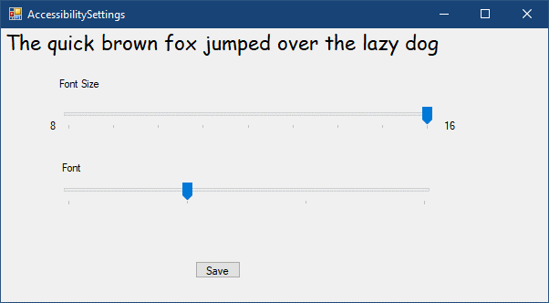

Maintenance and Report

The final stage of the project was used to ensure that user testing results had been implemented, focussing on bug fixing and quality of life changes within the application. Once the fixes had been implemented, focus centred around writing the report. This took a large amount of time as it required the centralisation of varying resources that had been throughout the whole of development. There were no challenges faced during this stage of the project.

Testing

15.1 Test Driven Development and Integration Testing

To ensure that an effective approach towards development that was robust and well tested, the developer adopted a Test Driven Development (TDD) approach. This allows for an iterative development that uses precise tests to ensure the application performs as expected. Once the code provides successful outputs, refactor the code to ensure that it is optimized and redundant (Unadkat, 2023). While this is traditionally done with unit tests, the approach used console outputs for constant checking that values are as expected.

While this was used for tests throughout the application’s development, specifically for integration of the authentication functions, Integration Testing was used to focus on the interaction of the functions overall impact on the applications performance. The result of this testing ultimately changed how the application ran during the authentication process – by instead running the functions as asynchronous tasks, this allowed for the application to continue being interactive for the user instead of locking them out, seemingly as if the application had crashed.

Functional Testing

To ensure that each function performed as expected, a black box approach was taken to test each subsection of the system. This allows for a versatile approach to testing to ensure that the product works as intended for the end user, rather than how the source code is expecting. Functional testing was used throughout development of the product to ensure that features worked as intended. Feedback provided resulted in quality-of-life changes within the project for the end user. An example of this would be a user managing to crash the programme by pressing backspace too many times during a password input.

To complete functional testing, a plan had been devised for each and all functional requirements. These can be found in the Appendix.

End of Project Report

Summary

Overall, the project was completed successfully. The project was able to provide a non-intrusive multi-modal authentication application that was consistent and accurate. Although there were challenges along the way regarding interface design and the creation of the machine learning model which caused the product to not be on schedule, all core and the majority of desirable features were implemented, and all product objectives were achieved.

Objectives Review

1. To research user experience (UX) interface design to allow for the application to be accessible to all users.
2. Build an application that uses multiple biometric modalities to authenticate.
This objective was considered a success. The application uses both image recognition and keystroke analysis to devise a confidence score based on the login attempt.
3. Build an application that allows for enforcement of access control for each individual authentication attempt.
This objective is considered a success – but mainly based on how a function returns the confidence score. The programme currently only returns confidence in the prediction which is two numbers that add up to a total of one, the greater number being either a zero for success or one for failure. This can be manipulated in future development and integration.

4. Design a user interface that is accessible and intuitive.

This objective has been partially met. While the interface has been designed to be accessible using allowing users to edit key aspects such as font size and font family, the visual design of the application is basic. This is due to the technologies that had been chosen to develop the application, and many libraries that are used to re-design the interfaces costing money. Although there was a library that was used, it wasn’t consistent with how it applied settings, and therefore was scrapped for a more basic design.

5. To follow agile project management techniques and complete a minimum viable product within the allocated time.

Overall, the objective should be considered a success despite setbacks. Many sprints were behind schedule or not worked on when scheduled. However, the minimum viable product was still completed during the allocated time and completed in an agile and iterative manner, while being version controlled. Albeit there were many core techniques to agile development that had been overlooked, and for future development or to start from scratch, would be incorporated for a more structured approach.

6. Create an unintrusive method of authentication to ensure users aren’t disrupted.

This objective is a complete success on sign up. The user follows a basic sign-up and sign-in process no different to a regular sign-up form to any application or web application. The design currently displays the image of the user while it is being taken as a way of alerting the user that their camera is in use.

Changes In Development

The main changes in development were database hosting, while for a large majority of the project, the database was hosted with AWS, due to unforeseen circumstances it had to be partially locally hosted during some parts of development. This took a chunk out of development at times to update the correct database at time of use. This generally was taken care of through the use of a Jupyter Notebook, however with micro changes throughout development and bug-fixing, not all were documented fully.

The addition of a real-time form during authentication was a change that was also made during development. This has been updated in the user stories. This was based off of feedback that during the authentication process, the user was unsure whether anything was happening or if the application crashed.

Project Post-Mortem

17.1 What Went Well?

The integration of the various biometrics into the application worked smoother than expected,

Lessons Learnt

Moving forward, I would want to design future project’s interfaces using a high level design tool such as Figma. While it is not a mobile application, it functions similarly enough. While I had a base understanding of how I wanted my application to look – it would have been easier to experiment with positioning and colour design. This would have also allowed for a more intuitive user testing, while also saving valuable time that could be used for further development.

Furthermore, more research should have been done into the technology used to design the GUI, as while the developer was aware of the limitations for designing the interface, it proved to be overly

Future Development

As the application stands, it is a suitable prototype that acts as an authentication app that is unintrusive and can provide a confidence score based on the biometrics provided. For future development:
- Add in an integration to any devices with fingerprint sensors as an optional for the user to potentially use for passwordless login.
- Add in more ways of experimenting with confidence score – allowing for a more human-approachable side of seeing Low, Medium, or High.
- Allow for admins to change passwords of users.
- Ensure that the Singleton design pattern is integrated to prevent webcam feed issues.
- Allow for users to retake their photo during sign up.
- Incorporate more information from keystroke dynamics, including length of key press.

Conclusion

The aim of the project was to create a form of authentication that fuses several biometrics to enforce access control, while also being non-intrusive to the end user. The project achieved all but one of the project objectives that were outlined but met all functional requirements. Although there were various setbacks during development, the project managed to finish as a success. The developer had never dealt with a project this large using various unfamiliar technologies and has considered the project a success. For future development of the project, it is hoped that other various types of biometrics could be included, such as speech recognition and fingerprint identification which can be added optional authentication methods for those who are prepared to achieve higher accuracy confidence ratings, while still maintaining its unintrusive nature.

References

Atlassian (2024) Scrum sprints: Everything you need to know, Atlassian. Available at: https://www.atlassian.com/agile/scrum/sprints (Accessed: 09 April 2024).
Atlassian (2024) What is agile?, Atlassian. Available at: https://www.atlassian.com/agile (Accessed: 09 April 2024).
OpenDyslexic (2024) OpenDyslexic. Available at: https://opendyslexic.org/related-research (Accessed: 09 April 2024).
Reese, K. et al. (2019) A usability study of five two-factor authentication methods, A Usability Study of Five Two-Factor Authentication Methods. Available at: https://www.usenix.org/system/files/soups2019-reese.pdf (Accessed: 17 April 2024).
Lei, Z. et al. (2021) On the insecurity of SMS one-time password messages ..., On the Insecurity of SMS One-Time Password Messages against Local Attackers in Modern Mobile Devices. Available at: https://www.ndss-symposium.org/wp-content/uploads/ndss2021_3B-4_24212_paper.pdf (Accessed: 18 April 2024).
One-time passcode verification (OTP) (2024) Twilio. Available at: https://www.twilio.com/code-exchange/one-time-passcode-verification-otp (Accessed: 18 April 2024).
Atlassian (2024) User stories: Examples and template, Atlassian. Available at: https://www.atlassian.com/agile/project-management/user-stories (Accessed: 18 April 2024).
Draffan, E.A. (2022) Multifactor Authentication – Cognitive Overload?, Lexdis 2.0. Available at: https://www.lexdis.org.uk/2022/02/multifactor-authentication-cognitive-overload/ (Accessed: 18 April 2024).
Atlassian (2024) What is version control, Atlassian. Available at: https://www.atlassian.com/git/tutorials/what-is-version-control (Accessed: 18 April 2024).
Keita, Z. (2022) Classification in machine learning, DataCamp. Available at: https://www.datacamp.com/blog/classification-machine-learning (Accessed: 19 April 2024).
Al-Rousan, T. (2022) (open access) new framework for improving Random Forest Classification Accuracy (2022), SciSpace - Paper. Available at: https://typeset.io/papers/new-framework-for-improving-random-forest-classification-1zs85mbp (Accessed: 19 April 2024).
IEvangelist (2024) Observer design pattern - .NET, .NET | Microsoft Learn. Available at: https://learn.microsoft.com/en-us/dotnet/standard/events/observer-design-pattern (Accessed: 19 April 2024).
Tanrıverdi, B. (2024) Implementing the strategy design pattern with keyed services in .net 8, Medium. Available at: https://medium.com/@baristanriverdi/implementing-the-strategy-design-pattern-with-keyed-services-in-net-8-9bf6995651d3 (Accessed: 19 April 2024).
Atlassian (2024) Scrumban: Mastering Two agile methodologies, Atlassian. Available at: https://www.atlassian.com/agile/project-management/scrumban (Accessed: 19 April 2024).
Understanding SC 1.4.3:contrast (minimum) (level AA) (2023) Understanding Success Criterion 1.4.3: Contrast (Minimum) | WAI | W3C. Available at: https://www.w3.org/WAI/WCAG21/Understanding/contrast-minimum.html (Accessed: 19 April 2024).
Computer Security Division, I.T.L. (2015) NIST policy on hash functions - hash functions: CSRC, CSRC. Available at: https://csrc.nist.gov/projects/hash-functions/nist-policy-on-hash-functions (Accessed: 19 April 2024).
Dinu, D. et al. (2015) P-H-C/PHC-winner-argon2: The password hash argon2, winner of PHC, GitHub. Available at: https://github.com/P-H-C/phc-winner-argon2 (Accessed: 20 April 2024).
Trello (2023) What is Trello?: Trello, Atlassian Support. Available at: https://support.atlassian.com/trello/docs/what-is-trello/ (Accessed: 20 April 2024).
Schneiderman, B. et al. (2017) Designing the user interface: Strategies for effective human-computer interaction, 6th edition, Designing the User Interface: Strategies for Effective Human-Computer Interaction. Available at: https://www.pearson.com/en-us/subject-catalog/p/designing-the-user-interface-strategies-for-effective-human-computer-interaction/P200000003485/9780137503889 (Accessed: 20 April 2024).
Saevanee, H., Clarke, N.L. and Furnell, S.M. (2012) Multi-modal behavioural biometric authentication for mobile devices, SpringerLink. Available at: https://link.springer.com/chapter/10.1007/978-3-642-30436-1_38 (Accessed: 21 April 2024).
Unadkat, J. (2023) What is Test Driven Development (TDD) ?, BrowserStack. Available at: https://www.browserstack.com/guide/what-is-test-driven-development (Accessed: 21 April 2024).

